|  |  |
| --- | --- |
| \\VFILERDPI\DPI-Home\OBRIENR2\My Documents\Downloads\PP logo.jpg |  |
| **COUNCIL ASSESSMENT REPORT**  NORTHERN REGIONAL PLANNING PANEL | |

|  |  |
| --- | --- |
| PANEL REFERENCE & DA NUMBER | PPSNTH-406 – Byron – DA10.2017.201.4 |
| PROPOSAL | Modification to Condition 1 of the Consent to establish Stage 4 Public Open Space during Stage 3, and consolidate open space/community lots in stage 3 |
| ADDRESS | 26 Harvest Boulevard, Byron Bay (Lot 56, DP1299678)  Lot 227 & 229, DP755695  Lot 7020, DP1113431 (portion of drainage reserve) |
| APPLICANT | Rob van Iersel, Planit Consulting |
| OWNER | NSPT Pty Ltd |
| DA LODGEMENT DATE | 16/12/2024 |
| APPLICATION TYPE | Section 4.56 Modification |
| REGIONALLY SIGNIFICANT CRITERIA | Section 2.19(1) and Clause 2 of Schedule 6 of *State Environmental Planning Policy (Planning Systems) 2021*  declares the proposal regionally significant development as:  Original DA  The original proposal was classified as “regionally significant development” as defined under Clause 20 of the now repealed SEPP (State and Regional Development) 2011 and Schedule 4A (3) of the Environmental Planning and Assessment Act 1979 (EP&A Act) as at the date of DA lodgement, the proposal was “Development that has a capital investment value of more than $20 million”.  S4.56  Clause 2, Schedule 6 of State Environmental Planning Policy (Planning Systems) 2021: General development over $30 million. |
| CIV | $35,384,706 |
| CLAUSE 4.6 REQUESTS | Not applicable |
| KEY SEPP/LEP | Relevant [environmental planning instrument](http://www.austlii.edu.au/au/legis/nsw/consol_act/epaaa1979389/s4.html#environmental_planning_instrument)s   * State Environmental Planning (Biodiversity and Conservation) 2021 * State Environmental Planning Policy (Planning Systems) 2021 * State Environmental Planning Policy (Resilience and Hazards) 2021   Relevant [Local Environment Plan](http://www.austlii.edu.au/au/legis/nsw/consol_act/epaaa1979389/s4.html#development_control_plan)   * Byron Local Environment Plan 1988   Relevant [Development Control Plan](http://www.austlii.edu.au/au/legis/nsw/consol_act/epaaa1979389/s4.html#development_control_plan)   * Byron Development Control Plan 2014   Relevant planning agreement  (VPA) 2013/8948 |
| TOTAL & UNIQUE SUBMISSIONS KEY ISSUES IN SUBMISSIONS | No submissions received |
| DOCUMENTS SUBMITTED FOR CONSIDERATION | * Attachment A: Conditions of consent * Attachment B: Amended staging plans * Attachment C: Current Conditions of consent under DA10.2017.201.3 |
| SPECIAL INFRASTRUCTURE CONTRIBUTIONS (S7.24) | Not Applicable |
| RECOMMENDATION | Approval |
| DRAFT CONDITIONS TO APPLICANT | 4 April 2025 |
| SCHEDULED MEETING DATE | 22 April 2025 |
| PLAN VERSION | * Overall Staging plan (28/02/2025) Revision C * Stage 1b Plan (28/02/2025) Revision C * Stage 2 Plan (28/02/2025) Revision C * Stage 3 Plan (28/02/2025) Revision C * Stage 4 Plan (28/02/2025) Revision C |
| PREPARED BY | Contracting Planner - Jordan Vickers |
| DATE OF REPORT | 4 April 2025 |

**EXECUTIVE SUMMARY**

The proposal seeks consent for a modification to Condition 1 of the consent for the Harvest Estate in the West Byron Urban release area.

The modification proposes to establish Stage 4 Public Open Space during Stage 3 and consolidate three open space/community lots into a single land parcel in Stage 3.

Currently, public open space adjacent to Ewingsdale Road is included as part of Stage 4, and it is requested to modify Condition 1 to indicate that this public open space is within Stage 3. Similarly, Stage 3 currently includes two community lots and a parcel of public open space; these properties are to be consolidated into a single community allotment.

The proposal involves an update to Condition 1 of the consent to refer to amended staging plans. The modification remains compliant with all Environmental Planning Instruments, including State Environmental Planning Policies, the Byron LEP 2014, as well as the Byron DCP 2014.

The modification was referred to the NSW RFS and have issued new General Terms of approval under Section 100B of the Rural Fires Act 1997.

The modification was publicly notified in accordance with Council’s Community Participation Plan from 10 January 2025 until 23 January 2025. The notification included the following:

* A sign placed on the site;
* Notification letters sent to adjoining and adjacent properties;
* Notification on the Council’s website.

No submissions have been received.

The proposed S4.56 Application to modify development consent DA10.2017.201.1 (as amended) raises no planning or environmental issues and in summary the establishment of the park at stage 3 as proposed is logical and will provide for formal open space for the new residents of the estate.

1. **THE SITE AND LOCALITY**
   1. **The Site**

The development site comprises numerous land parcels that form part of Harvest Estate in the West Byron Urban Release Area, including:

* 26 Harvest Boulevard, Byron Bay (Lot 56, DP1299678)
* Lot 227 & 229, DP755695
* Lot 7020, DP1113431 (portion of drainage reserve)

The development site is graphically depicted below:



Lot 56 DP1299678

Lot 227 DP755695

Lot 229 DP755695

Lot 7020 DP1113431

(Portion Drainage reserve

Figure 1: Development site

The generally level site is located on the southern side of Ewingsdale Road, opposite the Byron Arts and Industry Estate and is adjoined by premises for rural and large lot residential and environmental conservation and management uses. Much of the land is cleared, with areas of vegetation towards the south.

The approved development involved a wide range of environmental restoration, enhancement and landscape works. Significant rehabilitation, weed control and revegetation, have been undertaken. Figure 1 provides an aerial view of the site. Figure 2 provides an aerial view of the site including the West Byron Urban Release Area map, whilst Figure 3 depicts applicable Byron LEP 2014 Land Zoning Maps.

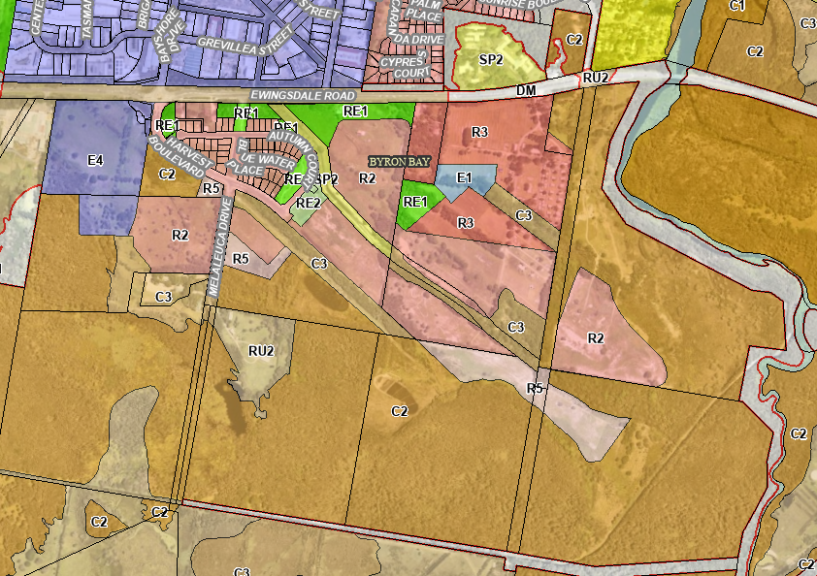

Figure 3: Development site and land zoning (Byron LEP 2014)

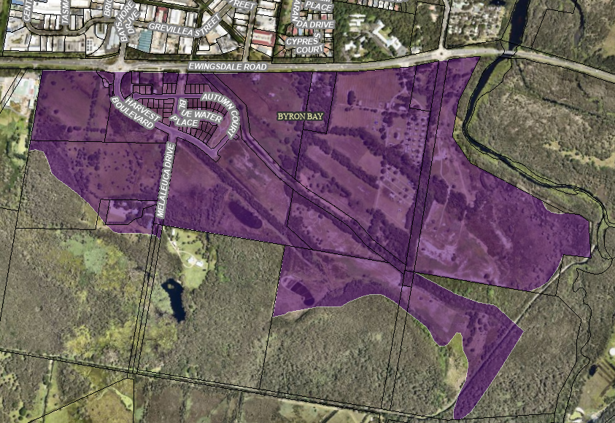

Figure 2: Development site & West Byron Urban Release Area

The development site is identified as liable to the following constraints:

* Flood liable land (1 in 100 year)
* Bushfire prone land (predominantly Vegetation Category 3 and 1)
* Acid sulfate soils (Class 2 and 3)
* High Environmental Value vegetation
* Koala Habitat (in accordance with Koala Plan of Management)
* Coastal Zone (Coastal Environment Area, Coastal Use Area, Coastal Wetlands & Coastal Wetlands buffer)
  1. **The Locality**
* To the immediate north is Ewingsdale Road followed by the Byron Bay Arts & Industry Estate, and the Sunrise Beach residential area;
* To the south is “coastal swamp forest” and at the terminus of Melaleuca Drive are three properties being the Planula Bed & Breakfast Retreat, the Temple Byron healing centre and the Vidal property;
* To the west is a former chicken processing plant and beyond this the Ewingsdale rural residential area; and
* To the east is the Belongil Fields caravan park, the approved Site R&D subdivision (10.2017.661.1) and beyond this Belongil Creek.
* The site is 2.5km west of the Byron Bay Town Centre; 2.6km east of the Byron hospital; adjacent to the main road; primary and secondary schools are located within 6km.

1. **THE PROPOSAL AND BACKGROUND** 
   1. **The Proposal**

The proposal seeks consent for a modification to Condition 1 of the consent to establish Stage 4 Public Open Space during Stage 3 and consolidate three open space/community lots in stage 3. Currently, public open space adjacent to Ewingsdale Road is included as part of Stage 4, and it is requested to modify Condition 1 to indicate that this public open space is within Stage 3 (refer plans below).

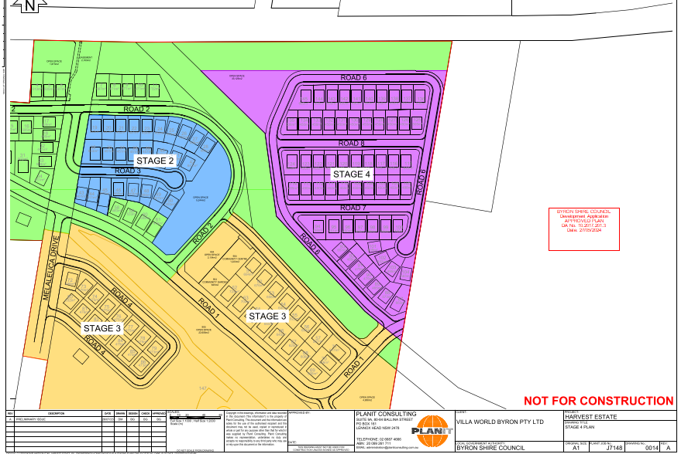

Figure 4: Approved subdivision staging. Note: circled area adjacent to northern boundary included in stage 4.

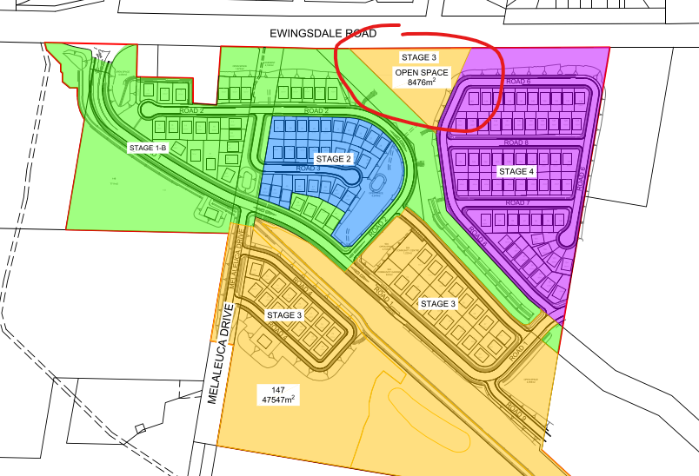

Figure 5: Proposed amended staging, where open spaces forms part of Stage 3.

Similarly, Stage 3 currently includes two community allotments and one open space lot (shown below in Figure 6) which are proposed to be amalgamated (Figure 7).

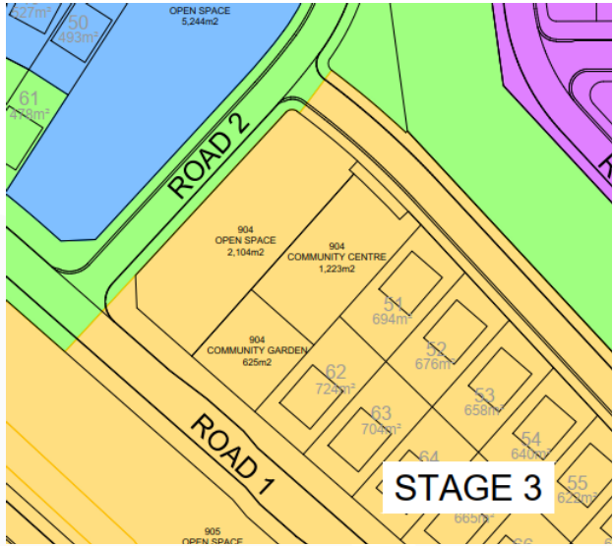

Figure 6: Approved community and open part of Stage 3.

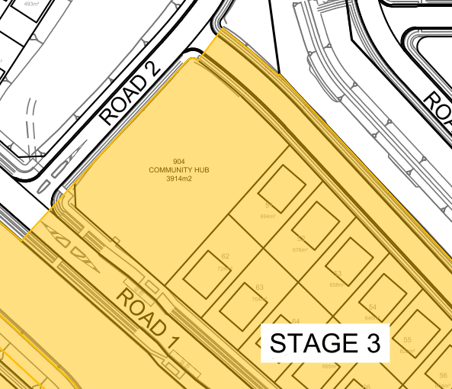

Figure 7: Proposed amalgamation Stage 3.

Specifically, the proposal involves modifying Conditions 1 and 3 of the consent to refer to amended staging plans. As part of the Modification, the Rural Fire Service have updated General Terms of Agreement, and Condition 8 and Schedule 1 are required to be updated. No further modifications to conditions of consent are required.

* 1. **Background**

The development application was lodged on **16 December 2024**. A chronology of the development application since lodgement is outlined in **Table 2**.

**Table 2: Chronology of the DA**

|  |  |
| --- | --- |
| **Date** | **Event** |
| 10 January 2025 | Exhibition of the application |
| 22 April 2025 | Panel briefing |

* 1. **Site History**

The Harvest Estate was approved in December 2020 by way of consent issued by the NSW Land and Environment Court (Villa World Byron Pty Ltd v Byron Shire Council [2020] NSWLEC 1612). The approval provided for the development to be undertaken in seven (7) stages. Modification to the consent under 10.2017.201.3 amended staging of the consent to be undertaken in four (4) stages, depicted in Figure 5 below.

Since this time, lots to Stages 1B and 2 have been registered. The proposed modification relates to land encompassed within Stages 3 and 4 depicted in Figure 6 which shows the most recent staging plan for the development.

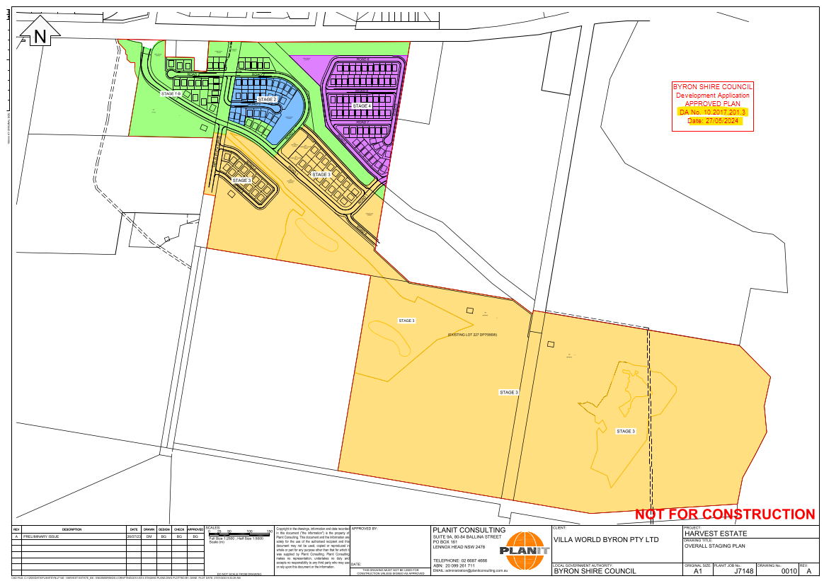

Figure 6: Most recently approved staging plan

| **Application** | **Detail** | **Outcome** |
| --- | --- | --- |
| 10.2017.201.1 | * Lodged - 10/5/2017 * Refused by NRPP – 8/4/2018 * Class 1 appeal lodged - 4/10/2019 * Conciliation – 20/8/2020 to 12/10/2020 * Amended proposal – August 2020 * Further conciliation – 6, 10 & 19 November 2020 * Approved NSW LEC consent orders 8 December 2020 (2019/310612) – Subdivision or 9 lots into 149 residential lots including: 145 smaller residential; 4 larger residential lots, 7 green infrastructure lots and associated works | Approved by NSW LEC |
| 10.2017.201.2 | * Modify staging timeframes and consequential amendments * Lodged 9/6/2021 * Public exhibition – 24/6/2021 to 21/7/2021 * Applicant amended proposal to retain 12 months groundwater monitoring between stages – 3/8/2021 * Applicant requested alteration of stage boundaries – 3/9/2021 | Approved 4/11/2021 |
| 10.2017.201.3 | * Amalgamate stages 7 – 4, remove time frame between stages, temporary fill stockpile, delete boardwalk, condition amendments. | Approved 27/05/2024 |

1. **STATUTORY CONSIDERATIONS**

When determining a development application, the consent authority must take into consideration the matters outlined in Section 4.15(1) of the *Environmental Planning and Assessment Act 1979* (‘EP&A Act’). These matters as are of relevance to the development application include the following:

1. *the provisions of any environmental planning instrument, proposed instrument, development control plan, planning agreement and the regulations*

*(i)  any environmental planning instrument, and*

*(ii)  any proposed instrument that is or has been the subject of public consultation under this Act and that has been notified to the consent authority (unless the Planning Secretary has notified the consent authority that the making of the proposed instrument has been deferred indefinitely or has not been approved), and*

*(iii)  any development control plan, and*

*(iiia)  any planning agreement that has been entered into under section 7.4, or any draft planning agreement that a developer has offered to enter into under section 7.4, and*

*(iv)  the regulations (to the extent that they prescribe matters for the purposes of this paragraph),*

*that apply to the land to which the development application relates,*

1. *the likely impacts of that development, including environmental impacts on both the natural and built environments, and social and economic impacts in the locality,*
2. *the suitability of the site for the development,*
3. *any submissions made in accordance with this Act or the regulations,*
4. *the public interest.*

These matters are further considered below.

It is noted that the proposal is not considered integrated development.

* 1. **Environmental Planning Instruments, proposed instrument, development control plan, planning agreement and the regulations**

The relevant environmental planning instruments, proposed instruments, development control plans, planning agreements and the matters for consideration under the Regulation are considered below.

1. **Section 4.15(1)(a)(i) - Provisions of Environmental Planning Instruments**

The following Environmental Planning Instruments are relevant to this application:

* [*State Environmental Planning Policy (Biodiversity and Conservation) 2021*](https://legislation.nsw.gov.au/view/html/inforce/current/epi-2021-0722)
* [*State Environmental Planning Policy (Precincts—Regional) 2021*](https://legislation.nsw.gov.au/view/html/inforce/current/epi-2021-0727)
* [*State Environmental Planning Policy (Resilience and Hazards) 2021*](https://legislation.nsw.gov.au/view/html/inforce/current/epi-2021-0730)
* [*Byron*](https://legislation.nsw.gov.au/view/html/inforce/current/epi-2021-0732) *Local Environmental Plan 2014*

A summary of the key matters for consideration arising from these State Environmental Planning Policies are outlined in **Table 3** and considered in more detail below.

**Table 3: Summary of Applicable Environmental Planning Instruments**

|  |  |  |
| --- | --- | --- |
| **EPI** | **Matters for Consideration** | **Comply** |
| State Environmental Planning Policy (Biodiversity & Conservation) 2021 | Chapter 4: Koala Habitat Protection 2021  In relation to koala habitat protection, the subject site falls within the area of an approved Koala Plan of Management under the State Environmental Planning Policy (Biodiversity and Conservation). In accordance with clause 4.8 of the SEPP, the Byron Coast Comprehensive Koala Plan of Management (BCCKPoM) applies. | Y |
| State Environmental Planning Policy (Planning Systems) 2021 | Chapter 2: State and Regional Development   * Section 2.19(1) declares the proposal regionally significant development pursuant to Clause 2 of Schedule 6 as it comprises General development over $30 million. | Y |
| SEPP (Resilience & Hazards) | Chapter 2: Coastal Management   * Section 2.7(4) – Development in coastal wetlands or littoral rainforest on the *Coastal Wetlands and Littoral Rainforests Area Map* * Section 2.8(1) -Development on land in proximity to coastal wetlands or littoral rainforest * Section 2.10(1) & (2) - Development on land within the coastal environment area * Section 2.11(1) - Development on land within the coastal use area * Section 2.12 - Development in coastal zone generally —development not to increase risk of coastal hazards.   Chapter 4: Remediation of Land   * Section 4.6 - Contamination and remediation has been considered in the original assessment and the proposal is satisfactory subject to conditions. | Y |
| Byron LEP 2014 | * Clause 2.3 – Permissibility and zone objectives | Y |

Consideration of the relevant SEPPs is outlined below:

[***State Environmental Planning Policy (Biodiversity and Conservation) 2021***](https://legislation.nsw.gov.au/view/html/inforce/current/epi-2021-0722)

***Chapter 4: Koala Habitat Protection 2021***

In relation to koala habitat protection, the subject site falls within the area of an approved Koala Plan of Management under the State Environmental Planning Policy (Biodiversity and Conservation). In accordance with clause 4.8 of the SEPP, the Byron Coast Comprehensive Koala Plan of Management (BCCKPoM) applies.

The management objectives for the West Byron Koala Management Precinct are “*to consolidate the existing sub-populations and improve the exchange of genetic material with other KMPs to the north and south*”.

The modification application does not seek to change the subdivision layout, extent of works, tree removal or retention or environmental restoration works. As such the proposed modification raises no specific issues and is generally consistent with the BCCKPoM as originally approved:

* Has a limited area of mapped koala potential habitat;
* Will retain some of the habitat but also result in the removal of some mapped koala potential habitat (see Figure 3);
* Commits to environmental restoration and enhancement works on several areas of the site which are expected to improve habitat connectivity and wildlife corridors;
* Will use “fauna neutral” plant species near Ewingsdale Road to help reduce road-strike;
* Commits to environmental monitoring during and following construction; and
* Will restrict the keeping of cats and dogs through registration of a restriction of use on property titles.

Figure 8 provides a Koala Habitat map under the CKPoM with area of habitat marked in green.

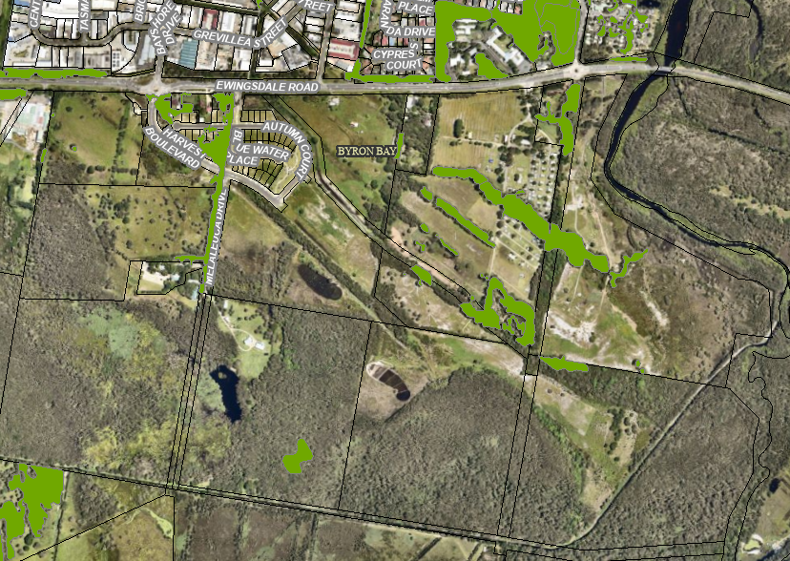

Figure 8: Koala Plan of Management area & development site

[***State Environmental Planning Policy (Resilience and Hazards) 2021***](https://legislation.nsw.gov.au/view/html/inforce/current/epi-2021-0730)

*Chapter 2: Coastal Management*

* Section 2.7(4) – The development site contains Coastal Wetlands and Council is satisfied that sufficient measures have been, or will be, taken to protect, and where possible enhance, the biophysical, hydrological and ecological integrity of the coastal wetland or littoral rainforest.
* Section 2.8(1) -The proposal is within the Coastal Wetlands proximity area and will not significantly impact upon:

1. the biophysical, hydrological or ecological integrity of the adjacent coastal wetland, or
2. the quantity and quality of surface and ground water flows to and from the adjacent coastal wetland.

* Section 2.10(1) & (2) - Development on land within the coastal environment area and the proposed development is unlikely to cause an adverse impact on:

1. the integrity and resilience of the biophysical, hydrological (surface and groundwater) and ecological environment,
2. coastal environmental values and natural coastal processes,
3. the water quality of the marine estate (within the meaning of the Marine Estate Management Act 2014), in particular, the cumulative impacts of the proposed development on any of the sensitive coastal lakes identified in Schedule 1,
4. marine vegetation, native vegetation and fauna and their habitats, undeveloped headlands and rock platforms,
5. existing public open space and safe access to and along the foreshore, beach, headland or rock platform for members of the public, including persons with a disability,
6. Aboriginal cultural heritage, practices and places,
7. the use of the surf zone.

* Section 2.11(1) - Development on land within the coastal use area and:

1. the proposed development is not likely to cause an adverse impact on:
2. existing, safe access to and along the foreshore, beach, headland or rock platform for members of the public, including persons with a disability,
3. overshadowing, wind funnelling and the loss of views from public places to foreshores,
4. the visual amenity and scenic qualities of the coast, including coastal headlands,
5. Aboriginal cultural heritage, practices and places,
6. cultural and built environment heritage, and
7. Council is satisfied that:
8. the development is designed, sited and will be managed to avoid an adverse impact referred to in paragraph (a), or
9. if that impact cannot be reasonably avoided—the development is designed, sited and will be managed to minimise that impact, or
10. if that impact cannot be minimised—the development will be managed to mitigate that impact, and
11. the surrounding coastal and built environment, and the bulk, scale and size of the proposed development have been taken into account.

* Section 2.12 – The proposed development is not anticipated to cause increased risk of coastal hazards on the property or adjacent land.

*Chapter 4: Remediation of Land*

Section 4.6 - Contamination and remediation has been considered in the original assessment (10.2017.201.1). The proposed modification raises no additional issues.

***Byron Local Environmental Plan 2014***

The relevant local environmental plan applying to the site is the *Byron Local Environmental Plan 2014* (‘the LEP’). The proposal is consistent with the aims of the LEP as the proposal seeks to provide public open space earlier in the rollout of the development.

The proposal does not modify any component of the development that triggers re-assessment against the provisions of the Byron LEP 2014 and is considered to be generally consistent with the LEP.

1. **Section 4.15 (1)(a)(ii) - Provisions of any Proposed Instruments**

There are no proposed instruments which have been the subject of public consultation under the EP&A Act which have implications for the proposal.

1. **Section 4.15(1)(a)(iii) - Provisions of any Development Control Plan**

The following Development Control Plan is relevant to this application:

* *Byron Development Control Plan 2014* (‘the DCP’)

| **Byron DCP 2014** | **Matters for Consideration** | **Comply** |
| --- | --- | --- |
| Chapter E8 West Byron Urban Release Area | Chapter E8 of the DCP 2014 applies to land identified as the West Byron Bay Site which includes the subject land of this development application. | Proposed modification raises no new issues against the DCP. The construction o the parkland as proposed is a sensible response to the staging of the development providing community facilities in a timely fashion for residents as they move to the estate. |

Development Contributions are payable under Byron S7.11 Development Contributions Plan 2014 in the current consent (10.2017.201.3). No variation to the contributions condition is required as the condition (Condition 114) is worded to provide flexibility for payment as a lump sum or proportional to any staging regime.

1. **Section 4.15(1)(a)(iiia) – Planning agreements under Section 7.4 of the EP&A Act**

The following planning agreement/s has been entered into under Section 7.4 of the EP&A Act:

A voluntary planning agreement (VPA) 2013/8948 was executed on 21 October 2014 between the Minister for Planning and the Byron Bay West Landowners Association (the developer) on Lots described as 5/DP622736, 6/DP622736, 1/DP542178, 227/DP755695, 229/DP755695, 9/DP111821, 1/DP1166535, 1/DP201626, 2/DP542178, 1/DP780242, 2/DP818403 and 1/DP520063. The executed agreement facilitates the delivery of the developer’s contribution towards the provision of regional infrastructure and to ensure conservation land is appropriately rehabilitated and maintained.

The proposal is consistent with this Planning Agreement.

1. **Section 4.15(1)(a)(iv) - Provisions of Regulations**

|  |  |  |  |
| --- | --- | --- | --- |
| **Environmental Planning and Assessment Regulations 2021** | **Applicable to the proposal:** | **Considered the control as it relates to the proposal:** | **If this control is applicable, does the proposal comply?** |
| Section 61 - Additional matters that consent authority must consider | N/A | N/A | N/A |
| Section 62 - Consideration of fire safety | N/A | N/A | N/A |
| Section 64 - Consent authority may require upgrade of buildings | N/A | N/A | N/A |
| Section 63 - Considerations for erection of temporary structures | N/A | N/A | N/A |

* 1. **Section 4.15(1)(b) - Likely Impacts of Development**

The likely impacts of that development, including environmental impacts on both the natural and built environments, and social and economic impacts in the locality must be considered. In this regard, potential impacts related to the proposal have been considered in response to SEPPs, LEP and DCP controls outlined above and the Key Issues section below.

The consideration of impacts on the natural and built environments includes the following:

| **Impact on:** | **Likely significant impact/s?** |
| --- | --- |
| **Natural environment** | No. The proposal will release public open space earlier in staging and will not adversely impact on the natural environment of the locality. |
| **Built environment** | No. The proposal will not have a significantly adverse impact on the built environment of the locality. |
| **Social Environment** | No. The proposal will not have a significant adverse social impact on the locality. |
| **Economic impact** | No. The proposal will not have a significant adverse economic impact on the locality. |

Accordingly, it is considered that the proposal will result in any significant adverse impacts in the locality as outlined above.

* 1. **Section 4.15(1)(c) - Suitability of the site**

The proposed modification is not considered to impact on the suitability of the site for the development.

* 1. **Section 4.15(1)(d) - Public Submissions**

These submissions are considered in Section 5 of this report.

* 1. **Section 4.15(1)(e) - Public interest**

The proposal is unlikely to prejudice or compromise the public interest or create an undesirable precedent.

1. **REFERRALS AND SUBMISSIONS**

The proposed modification was publicly exhibited. No submissions were received.

* 1. **Agency Referrals and Concurrence**

The development application has been referred to various agencies for comment/concurrence/referral as required by the EP&A Act and outlined below in Table 5.

There are no outstanding issues arising from these concurrence and referral requirements.

**Table 5: Concurrence and Referrals to agencies**

| **Agency** | **Concurrence/**  **referral trigger** | **Comments**  **(Issue, resolution, conditions)** | **Resolved** |
| --- | --- | --- | --- |
| Concurrence Requirements (s4.13 of EP&A Act) | | | |
| N/A |  |  |  |
| Referral/Consultation Agencies | | | |
| NSW Land and Environment Court | DA 10.2017.201.1 was approved by the NSW LEC. The LEC were notified of the subject S4.56 modification pursuant to S 107 of the EP&A Regulation 2021. | No response from the LEC required. | Y |
| Integrated Development (S 4.46 of the EP&A Act) | | | |
| RFS | Bush fire safety authority GTA’s issued under S100B - *Rural Fires Act 1997* for DA 10.2017.201.1 (subdivision). The subject S4.56 also referred to NSW RFS under S100B. | The 4.56 modification application has been referred to the Rural Fire Service for comment.  The RFS issued an updated Bush Fire Safety Authority and general terms of approval (GTA), which have been incorporated into the recommendations for approval. | Y |

* 1. **Council Officer Referrals**

Due to the minor nature of the proposed modification no internal referrals were required for this modification.

* 1. **Community Consultation**

The proposal was notified in accordance with the Council’s Community Participation Plan from 10 January 2025 until 23 January 2025. No submissions were received.

1. **KEY ISSUES**

The following key issues are relevant to the assessment of this application having considered the relevant planning controls and the proposal in detail:

* There are no key issues associated with this modification.

1. **CONCLUSION**

This s4.56 modification application has been considered in accordance with the requirements of the EP&A Act and the Regulations as outlined in this report. Following a thorough assessment of the relevant planning controls, issues raised in submissions and the key issues identified in this report, it is considered that the application can be supported.

It is considered that the key issues as outlined in Section 6 been resolved satisfactorily through amendments to the proposal and/or in the recommended draft conditions at **Attachment A**.

1. **RECOMMENDATION**

That the Development Application DA10.20147.201.4 for modifying the development staging at 342 Ewingsdale Road, Ewingsdale be APPROVED pursuant to Section 4.16(1)(a) of the *Environmental Planning and Assessment Act 1979* subject to the draft conditions of consent attached to this report at Attachment A.

The following attachments are provided:

* Attachment A: Conditions of consent
* Attachment B: Amended staging plans
* Attachment C: Existing Notice of Determination S4.56 - DA10.2017.201.3